**Create a simple cloud web application for student counselling system using any Cloud Service Provider to demonstrate SaaS with the fields of student name, age, address, phone, subjects studied, Year of passing, percentage of marks, domain interest, etc.**

**AIM:**

Create a simple cloud software application for Property Buying & Rental process (In Chennai city) using any Cloud Service Provider

**PROCEDURE:**

**STEP 1:**

Open browser and get into zoho ceator. Then sign in and click “Create application”. Below given screenshot will appear, hear type the application name of your Aim.

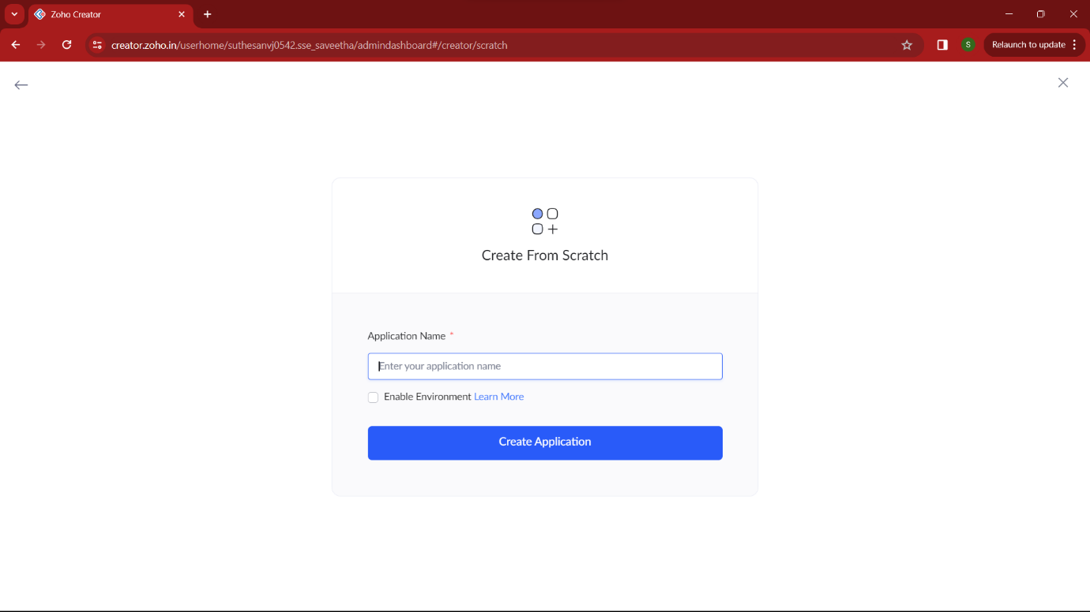

**STEP 2:**

Then select “start from scratch” option and select the proper component from the 4 components listed. For my application I just selected “forms” for the login credentials.

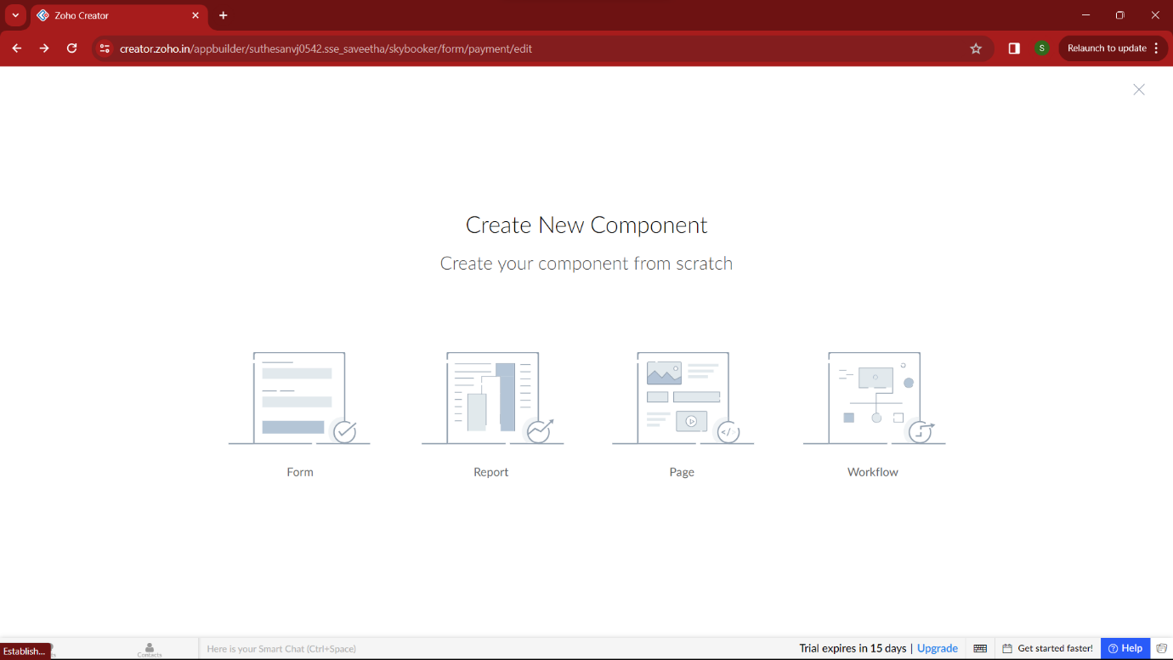

**STEP 3:**

In forms, below given options will be given. From here we can get sample templates of our requirements, otherwise we can import already saved schema for our application. I just selected “ from scratch” option for my application.

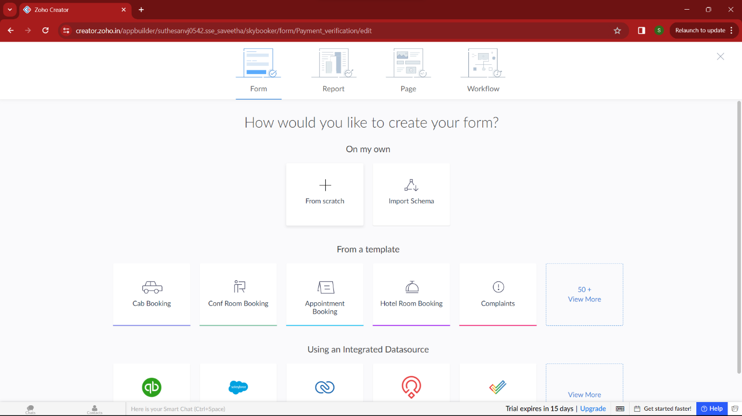

**STEP 4:**

Then provide an appropriate name for our application in the name form which shown below. I gave “StudentPathConnect” for my “Student counselling system”

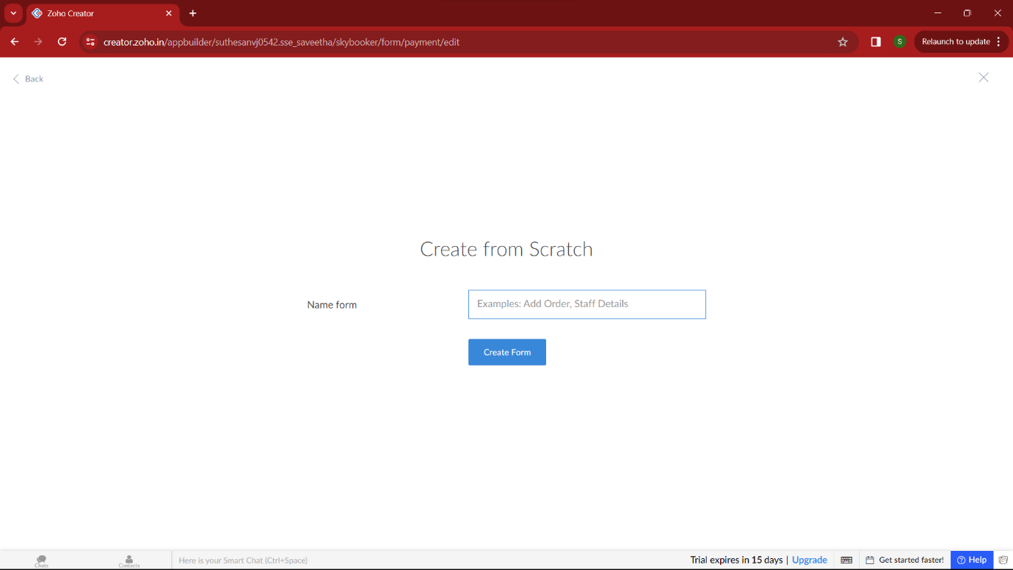

**STEP 5:**

by clicking “+” symbol shown in the picture given below, we can add number of forms in our application. Firstly I placed login form in my application with the essential credent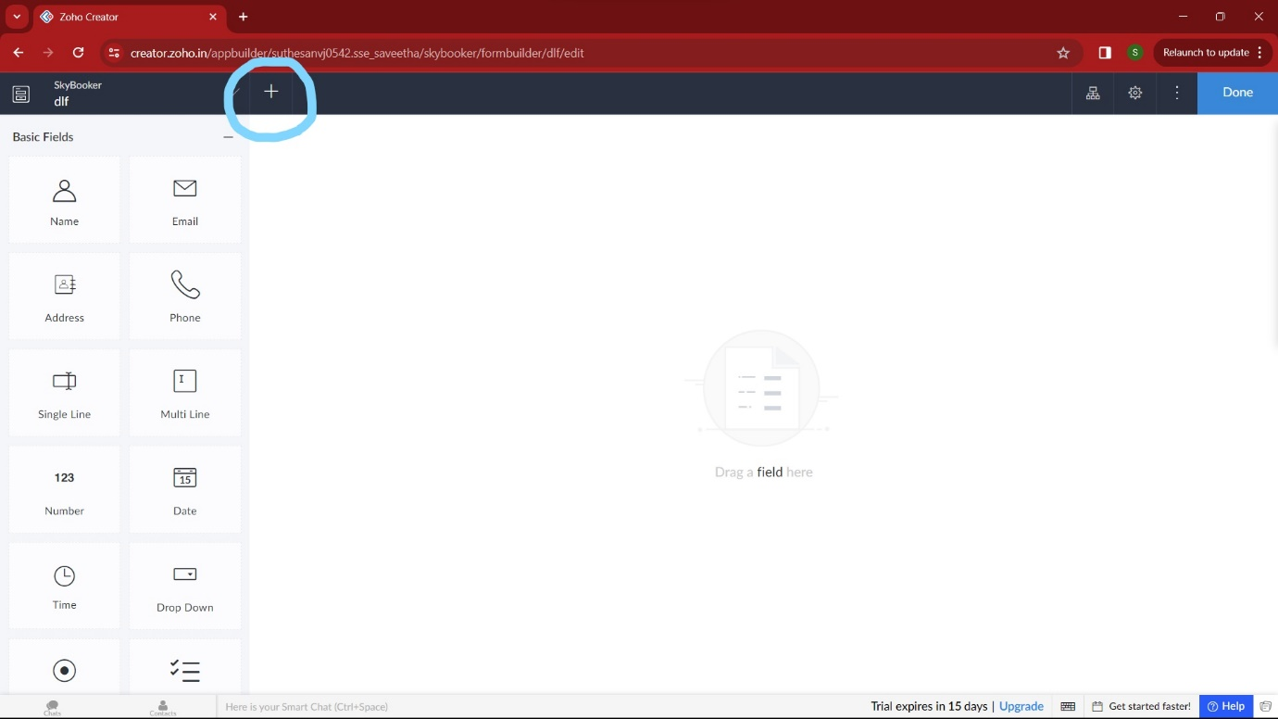

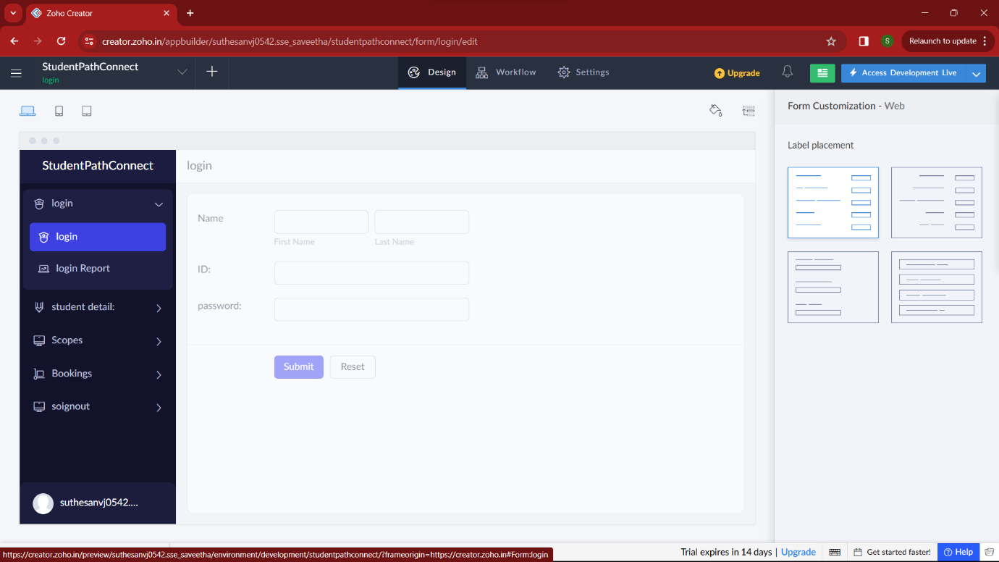

**STEP 6:**

Then I added another form namely “student details”. It contains all the details of the students which is helpful for the counselling.

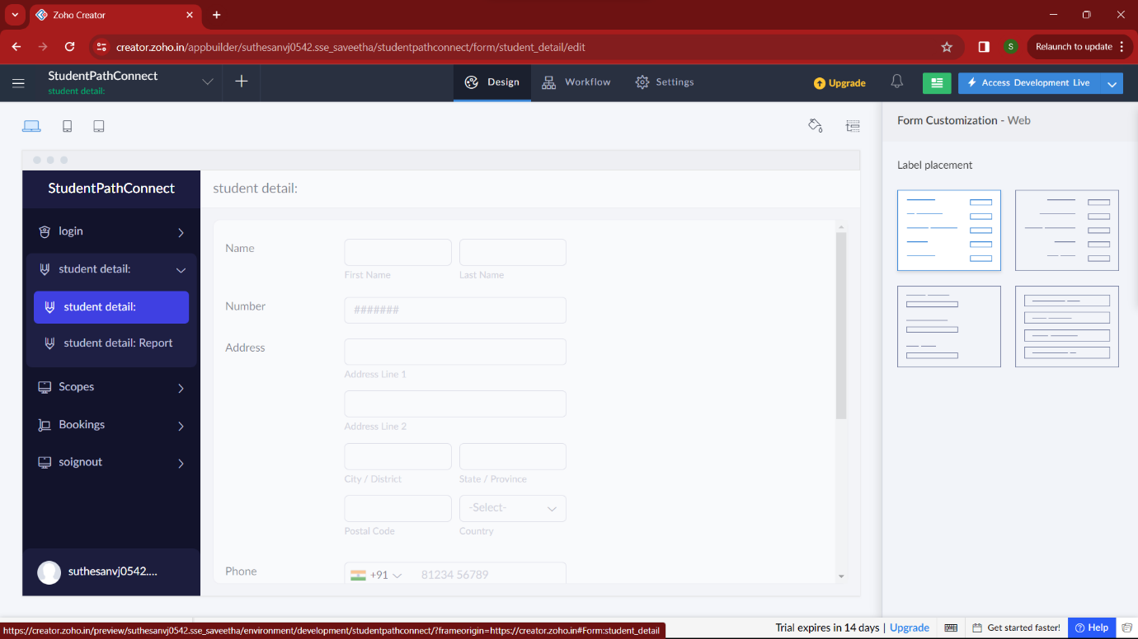

**STEP 7:**

Then I added another form namely “Scope” which searches the college, degree regarding the details of the student.

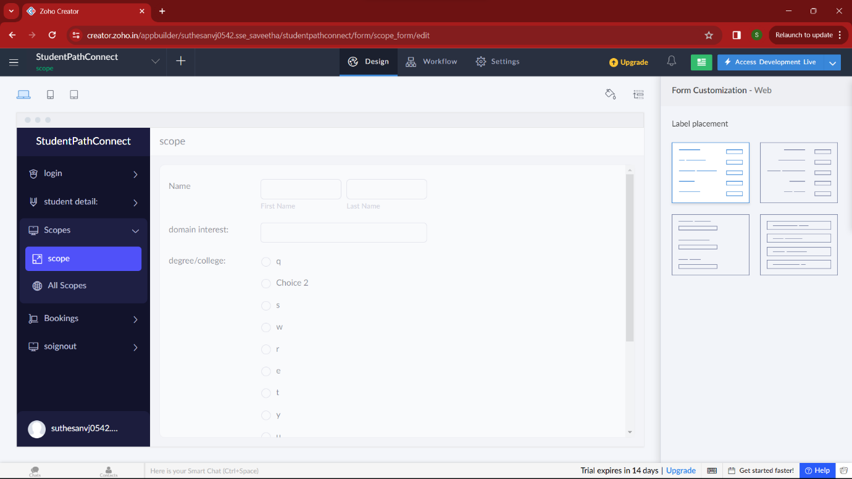

**STEP 8:**

Then in the next form I added “booking” of the selected thing. Here user can register for the college/degree according to their wish.it also displays the appointment of the counselling.

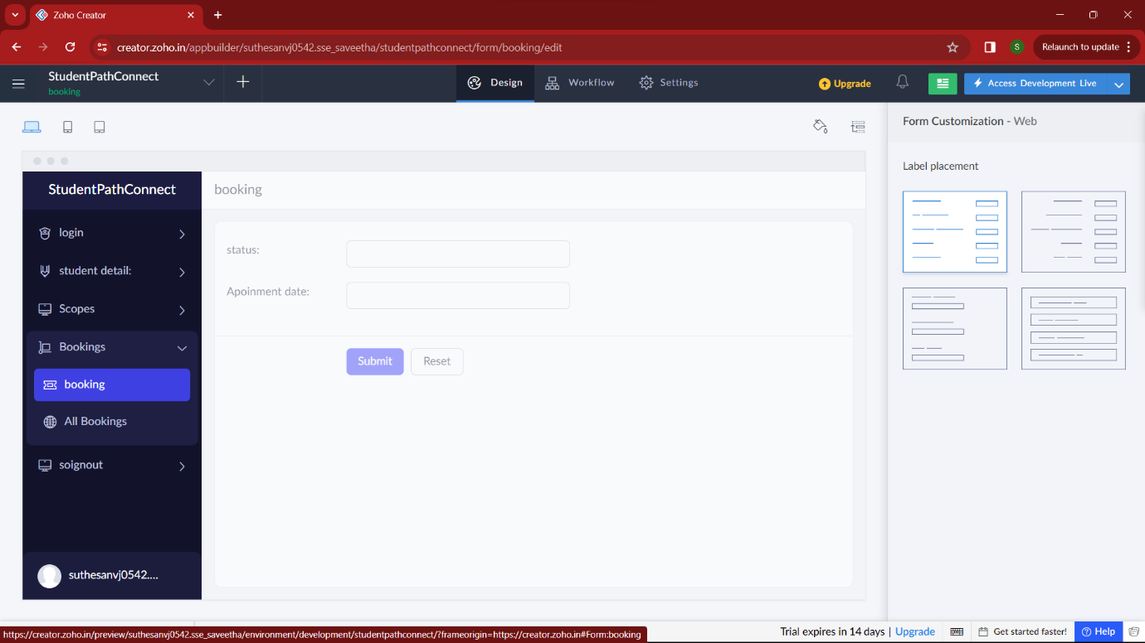

**STEP 9:**

In this form , after registering user can logout with the proper credentials.

